בעה'י
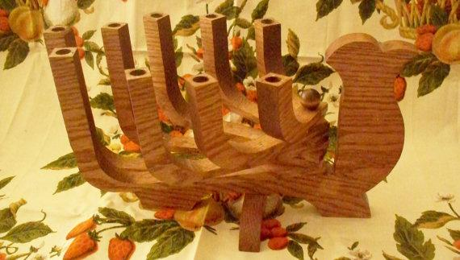
סֵפֶר
שְׁמונַת יְמֵי הוֹדָאָה

Eight Days of Thanksgiving:
Meditations for the Curious Confluence
of Hanukah and America’s Feast Day

by

Rahmiel Hayyim Drizin

Kislev 5774

I am not a fan of American Thanksgiving.

Now, I do not come here as a proverbial “Grinch who stole Thanksgiving.”

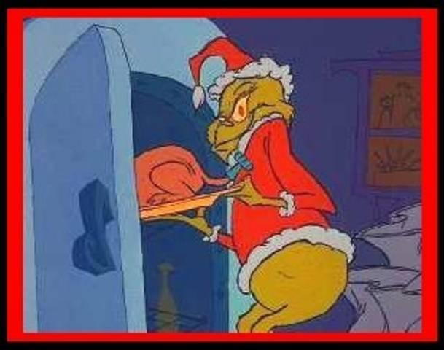

Rather, as a Torah-observant Jew, I have serious objections about a secular holiday that claims to signify giving thanks when the name “Jew” itself connotes “thanks”. Our daily liturgy is bountiful with prayers and praises invoking the Hebrew root הוֹד Hod meaning “thanks.” Moreover, any secular annual feast on a Thursday night cannot but somewhat diminish oneg/delight of the Holy Shabbat which will come less than 24 hours away. Those who gorge on lavish tables laden with thousands of calories most certainly will not approach the Holy Shabbat with the appetite required by halacha. Moreover, it is difficult to withstand the temptation to just use your Thanksgiving leftovers as the mainstay of your meals on Holy Shabbat. And frankly, my over fifty-years’ experience with the holiday reveals that its biggest fans tend to have eating issues: either (a) they could stand to lose a few pounds or (b) their focus on the culinary preparation belies their anorexic approach to food consumption. For a day whose history is chock-full of problematic questions, it is amazing that it still captures the modern import American gives it.

This is not the place for a halachic analysis of whether Thanksgiving is kosher. Interested readers are commended to review the fine treatment found at http://www.tfdixie.com/special/thanksg.htm .

What this is the place for is to take the “groove” engendered by Thanksgiving, namely the Jewish practice of giving thanks, relating it to the Holy Day of Hanukah--which this year unusually falls on Thanksgiving-- and using it as a springboard for eight days of daily meditations on the root הוֹד Hod. [see page 18 below] There are some rather surprising synchronicities between Hod and Thanksgiving. According to Kabbalah, each weekday represents a different mystical energy. Sunday is Chesed/ loving kindness, Monday is Gevurah/strength, Tuesday is Tiferet/beauty, Wednesday is Netzach/ endurance, Thursday is Hod/thanksgiving, Friday is Yesod/fundament, and Shabbat is Malchut/sovereignty. By law, Thanksgiving must fall on a Thursday, the day of Hod, that of thanksgiving. Moreover, what is served on Thanksgiving, but תרנגול הודו Tarnegol Hodu, “Hodu” bird, or “rooster from India”, our beloved Turkey (remember that Columbus was trying to discover a route to the Indies; this name belies its Old World viewpoint). Note how הודו Hodu has the root הוֹד Hod.

The exciting thing about this Thanksgiving is its potential to turn a secular food orgy into a seudat mitzvah. On Hanukah, there is no obligation to have festive meals; however it is customary to celebrate by eating special meals anyway, because of the fact that the dedication of the Temple and Altar took place during Hanukah. It is customary to sing during these Hanukah meals songs that thank and praise Hashem. To sing and speak about Torah can make this year’s Thanksgiving meal into a seudat mitzvah, a meal of religious significance.

While we are discussing the Thanksgiving – Hod relationship, we would do well to see the Hanukah-Sukkot-Thanksgiving connection.

The First Hanukah was actually a Sukkot Celebration
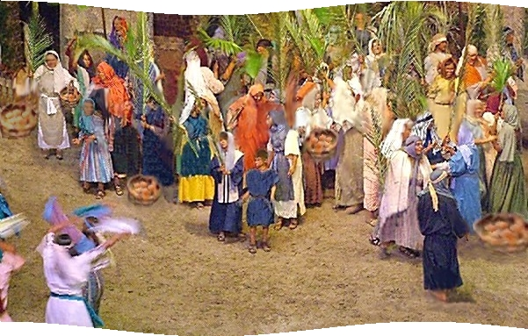
In addition to the victory parades of the ancient Maccabees that celebrated their political independence, the original holiday also took the form of a Temple Rededication Ceremony.

In the Second Book of the Maccabees, which quotes from a letter sent circa 125 BCE from the Hashmoneans to the leaders of Egyptian Jewry, the holiday is called "The festival of Sukkot celebrated in the month of Kislev (December)," rather than Tishrei (September). Since the Jews were still in caves fighting as guerrillas on Tishrei, 164 BCE, they could not properly honor the eight-day holiday of Sukkot (and Shemini Atzeret), which is a Temple holiday; hence it was postponed until after the recapture of Jerusalem and the purification of the Temple.

This--not the Talmudic legend of the cruse of oil--explains the eight day form of Hanukah. The use of candles may reflect the later reported tradition of Simchat Beit HaShoava (Water-drawing Festival), the all-night dancing in the Temple on Sukkot, which required tall outdoor lamps to flood light on the dance floor of the Temple courtyard.

"They celebrated it for eight days with gladness like Sukkot and recalled how a little while before, during Sukkot they had been wandering in the mountains and caverns like wild animals. So carrying lulav [palm branches waved on Sukkot]...they offered hymns of praise (perhaps, the Hallel prayer) to G-d who had brought to pass the purification of his own place" (II Maccabees 10:6-7).

The connection between Sukkot and Hanukah (as the Rabbis later called it) goes beyond the accident of a postponed Sukkot celebration. Sukkot is the holiday commemorating not only the wandering of the Jews in the desert in makeshift huts but the end of that trek with the dedication of the First Temple (i.e. the permanent Bayit/ Home of G-d in Jerusalem by King Solomon circa 1000 BCE):

"King Solomon gathered every person of Israel in the month of Eitanim (Tishrei) on the holiday (Sukkot) in the seventh month…for G-d had said, 'I have built a House for my eternal residence'" (I Kings 8:2, 12).

Thus the Maccabean rededication celebration is appropriately set for eight days in the Temple.

Did Sukkot help shape America’s Thanksgiving?
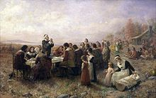

According to Dr. Jonathan Sarna, the biblical holiday of Sukkot did not exactly guide the Puritans’ thinking during colonial times, but they were generally influenced by the idea of thanking G-d for their bounty. Sarna notes that “The Puritans did not believe in fixed holidays. If it was a good season, they would announce a thanksgiving, but it’s not like the Jewish holiday which occurs on the 15th of the month of Tishrei (Sukkot). They did not believe in that. So in that respect it’s different.” In terms of thanking G-d for a bountiful harvest, the Puritans did learn that from the Torah. Sarna explains: “They knew what they called the Old Testament, what we call the Torah, they knew it, and they were influenced by it,” he said. “Now they didn’t go out and build huts, obviously. But the notion that one would be thankful for a bountiful harvest was certainly one they would have learned from the Torah.”

Thanksgiving did not become a fixed holiday in America until President Abraham Lincoln declared it as such in 1863. The holiday also did not have a firm date until Congress established one—the fourth Thursday of each November—in 1941.

Although “you’ll commonly read all over the place” about the connection between Thanksgiving and Sukkot, Sarna admitted that Diana Muir Applebaum—a Massachusetts-based historian who wrote the book “Thanksgiving: An American Holiday, An American History”—set him straight on the subject when he consulted with her. She wrote that “the Separatists at Plymouth did not create an annual holiday [of Thanksgiving]. Rather, a holiday that grew in popularity and stabilized into an annual celebration over the course of several decades was later traced back to an event that took place at Plymouth in December 1621. The thesis of her book on Thanksgiving is that it is a holiday rooted in the deeply held convictions of the New England settlers, and in the human love of a holiday.”

But one could ask if the Torah have any influence on the Puritans’ festival of thanks?

Applebaum explains that the Puritans separated the laws of the Hebrew Bible into two categories. “Some were deemed moral commandments, these applied to all men, at all times. The others were regarded as ceremonial or temporal commandments, which applied only to Jews, or only to the olden days, but not to Christians.”

For Puritans, the Sabbath was an eternal, moral commandment applying to Christians, but they considered Sukkot, Pesach, Shavout, kashrut, and other laws to be ceremonial or temporal commandments, not intended by G-d to apply to the children of the new covenant, Christians. Puritan theology “supported the proclamation of special days of prayer when unusual events occurred.

Applebaum writes: “In the event, for example, of an epidemic, drought, or famine, it was appropriate to call a special day of prayer and fasting in the hope that if the people repented, G-d would grant relief. In the event that G-d did grant a special providence, such as the lifting of a drought or famine, a special day of prayer and thanksgiving would be proclaimed.”

There were robust debates among the Puritans in the mid-1600s over the propriety of issuing a proclamation of a day of thanksgiving every autumn. Was an ordinary harvest a routine event, or was it a special providence? Applebaum writes:

“[People feared that] proclaiming a day of thanksgiving every autumn might ‘harden the people in their carnal confidence’ of G-d’s grace, and people might begin to take G-d’s gifts for granted. If a proclamation was expected every year, how was it different from the unbiblical Catholic error of creating fixed annual holidays? On the other hand, [some thought] G-d’s great bounty in sending the harvest was surely worthy of thanksgiving. And people like holidays. In years when the General Court (the Massachusetts legislature) failed to proclaim a day of thanksgiving, individual congregations sometimes did.”

After 1676 in Connecticut, and by the 1690s in Massachusetts, the government of each of those colonies proclaimed a special day of prayer and thanksgiving every autumn. It was celebrated by families returning home to celebrate, with special dishes (mince pie and plum pudding) eaten at Christmas in old England, and with events like ballgames on the village green that would have been inappropriate violations of a Sabbath day.

While we cannot be certain about what motivated those Pilgrim settlers to initiate a feast of thanksgiving, it is likely that they consciously drew on a model well-known to them from the Bible they cherished. Seeing themselves as new Israelites in a new ‘promised land,’ the Pilgrims surely found inspiration in the Bible, in the Books of Leviticus and Deuteronomy, in which G-d commands the ancient Israelites to observe the Feast of Booths—in Hebrew, Sukkot, ‘To rejoice before Hashem your G-d’ at the time of the fall harvest.

Hanukah as Hod
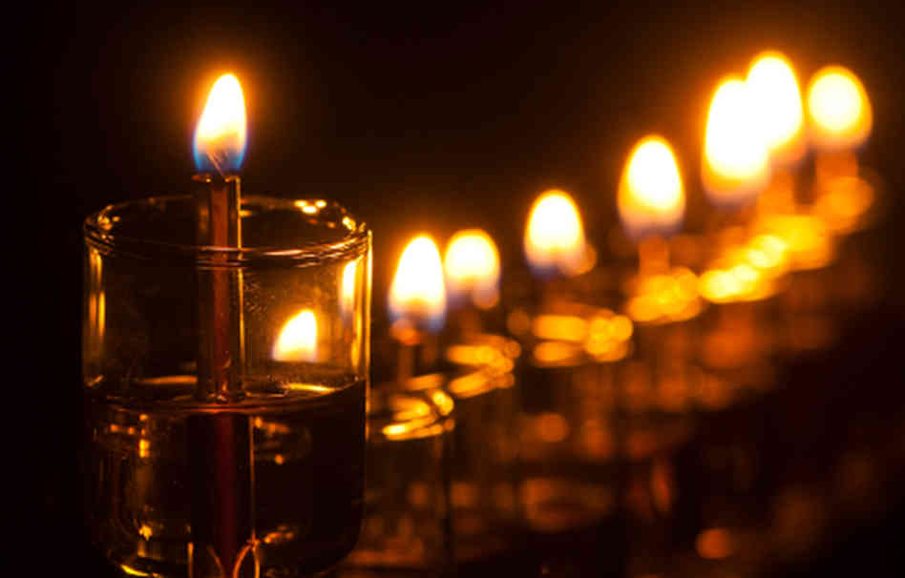
According to most mystical commentaries, Hanukah correlates with Hod/thanksgiving.
We can see this straightforward from the Al HaNissim prayer we add to our Tefilah and to our After-Blessings for Bread. There we say several times daily

וּבְהוֹדָאָה בְּהַלֵּל אֵלּוּ חֲנֻכָּה יְמֵי שְׁמוֹנַת וְקָבְעוּ

“and [the Sages] fixed these 8 days of Hanukah for praise and Hoda’ah/thanksgiving.”

The Sages themselves demarcate Hanukah for Hod-ing, thanksgiving.

Hanukah is relates to the middah (concept/attribute) of Hod, which besides thanksgiving also connotes light or brightness – it represents a unique inner shining quality that an entity has. [ Rav Hirsch to Daniel 10:8] Usually people look at something — whether it is people or pieces of knowledge — and they glance at its basic outer layer. However, there are usually deeper layers of significance that the sweep on an eye doesn’t catch. People are very complex and unique; factual information can have deeper implications and meaning. This concept of Hod/deeper essence was a big part of the battle between the Jews and their enemies in the story of Hanukah.

There is no physical difference between the boards, stones and metal of an animal barn and the boards, stones and metal of the Israelite temple that stood in Jerusalem. What separates the two sets of components is that some have been declared kadosh (set aside as religious items) and the others have not. There is a ―deeper yintangible component to the items. The Greeks banned Shabbat observance, circumcision, and the sanctification of Rosh Chodesh. Though they believed in powerful gods and they had philosophers who had conceptions of spiritual or metaphysical realms, they wanted to do away with the deeper components of Judaism in order to marginalize the religion. These three commandments reflect kedusha, setting aside of religiously significant entities, the kedusha of the body and time.

If one wishes to dismiss another’s faith, he or she will denigrate it and declare it to have no religious significance or connection to the spiritual. Those taking the scientific approach, as was developing during the story of Hanukah, do much of the same. There is great merit in studying, measuring and categorizing the components of the physical universe; but if one does not remember that there is a G-d who made and makes it all exist, he or she runs the risk of appreciating and elevating the intelligent creation, not the intelligent Creator.

Hod permeates Hanukah. An invisible G-d, beyond what a superficial glance may see, supported lights for eight days; the fire that burns those lights brings out the inner components of the oil and wick through combustion. Hod reminds us to stop and look for the inner specialness that people have, so that we can appreciate them, just as Aharon HaKohen, the prototype of Hod, would do. It urges us to trust in a Being that is beyond the physical, but provides miracles to save us and support for us each and every day.

The commandment to publicize the miracle of Hanukah demands that we light our menorahs in a place visible to passers-by and at a time not so late that no one will be found in the streets to see them. The above term hints that the power of Hanukah is so great that, during the holiday, the loftiest of supernal levels of holiness (represented by the above unification of divine names, the "foot" - or "regel") are actually accessible even in the lowest of realms. These less than lofty dominions are represented by the term "marketplace" (in Hebrew, "shuk", related to the word for "thigh", associated with the Sefirah of Hod, the eighth Sefirah from above), a place characterized by diffusion, disharmony, and susceptibility to the External Forces. Hanukah shows us that sparks of holiness are everywhere and gives us the ability to redeem them, shining holy light even in realms of darkness.

There are two holidays that are built around the number eight. The first is Shemini Atzeret, עצרת שמיני . The second is Hanukah. In the Peri Etz Cha’yim of Rav Yitzchak Luria, the holy Ari, we read that when the angel dislocated Ya’akov Avinu’s thigh, he damaged the Sefirah of Hod – הוד . And the repair work was accomplished by Matityahu and his sons. Thus, Hanukah celebrates the Tikkun of Hod –הוד. On the basis of this, the Rebbe of Slonim asks an unusual question. Hod – הוד is the eighth of the Sefirot, counting down from the first Keter. This represents the very lowest, distressed level of spirit that existed during the Greek occupation of Eretz Yisra’el. However, at the end of Ma’oz Tzur (צור מעוז ), we sing, “Men of insight –בינה בני – established eight days for song and jubilation.” Matityahu and his sons are described as men of insight and understanding - בינה בני. Binah, בינה , is the eighth Sefirah when you count from the bottom up, from Malchut, מלכות.

So, what exactly are the spiritual currents and processes set into motion on Hanukah, asks the Slonimer Rebbe?

In defeating the Greeks and initiating the miracle of the lights in the Temple, the Chashmona’im did indeed rise from the depths to the eighth level above, the level of Binah, בינה . The number eight symbolizes the ascent beyond the natural, physical world and with the miracles of Hanukah, the Jews indeed experienced supernatural, divine intervention in their lives.

However, the ascent to the level of Binah, בינה , resulted in a concomitant descent of the Shechinah into the lowest darkest levels of the Jews experience. On Hanukah, we place the Menorah below ten handbreadths to indicate that the light of the Hanukah candles spreads the light of the Shechinah into every dark dank hidden, dark corner of our souls and of our lives. The light of the Hanukah candles brings G-d’s glory, His Hod – הוד into our darkest moments, dispelling our fears, despair and distress while lighting up our lives with His goodness.

Every holiday and festival on the Jewish calendar has its own uniqueness. For instance, the difference between Shabbat and the Festivals is that on Shabbat, G-d welcomes us into His abode. We rise above our mundane existence to enter His palace. During the Festivals, the King comes to visit us where we live. G-d enters our homes and rejoices with us. However, there is a third situation: Hanukah. Instead of visiting in the King’s palace or welcoming Him into our home, He searches for us, only to find that we have fallen into a grimy, filthy cesspool. The King does not wait for help to arrive. He, himself, in all of his finery descends into the cesspool, grabs hold of his sons and daughters and lifts them out. “This is the light of Hanukah that shines brightly even below ten handbreadths.” (Netivot Shalom, Ma’amaray Hanukah, p. 46)

What is this “Hod”?

Hod, as described by Rabbi Yitzchok Ginsburgh, is associated in the soul with the power to continually advance, with the determination and perseverance born of deep inner commitment, toward the realization of one's life goals. The acknowledgment of a supreme purpose in life, and the total submission of self which it inspires, serve to endow the source of one's inspiration with an aura of splendor and majesty. Hence the word Hod connotes both "acknowledgment" (hoda'ah) and "splendor," in the sense of an aura-like "reverberation" (hed) of light.

The hoda'ah aspect of Hod also manifests itself as the power to express gratitude (thus qualifying it as a sefirotic response to chesed), as well as the power of "confession" (vidui)

Spiritual vision is associated with the sefirah of Hod. This is particularly important in that the appellation "Jew" (Yehudi), comes from the name of the tribe of Judah (Yehudah), whose word-root is Hod. Hod represents a number of attributes in the soul--"praise" and "thanksgiving" (hodaya), "acknowledgment" (hoda'ah), "confession" (vidui) and "glory"(Hod)--all having the word Hod as their root. The common characteristic to them all is the consciousness of surrendering to a higher Divine power in the world and the soul. This property is similar to that of selflessness and making oneself "small": "for you were the fewest of peoples."

The word “vidui” or confession stems from the same root as hoda’ah, which can mean either confession or thanks. This is not mere coincidence; both words are in essence the same. Hoda’ah is at the core an act of acquiescing to another person, bending the “I” to “you.” Thus, when a person owes someone money, he may admit to this fact (hoda’at ba’al din), declaring that the money that is purportedly his is actually the other person’s. When someone gives me a gift or renders me a service, I thank him (modeh, todah). The thanks are an acknowledgement that “my” object is actually “yours”, and I did not acquire it because of my productivity and industry. Likewise, when I confess (modeh, vidui, hoda’ah), I am making a statement of acknowledgement, acquiescence, and submission to G-d. I have wronged You: “Lecha Hashem hatzedakah velanu boshet hapanim – To You, O G-d, belongs charity, while we are shamefaced.”

Who is a Jew?

The question has, in recent years, given rise to bitter debate within our people. By discovering the origin of our name, we will gain an insight into our true purpose in this world; we may, at least, come closer to answering the question, "What is a Jew?"

Yaakov left home to take a wife from the family of Avraham in Padan Aram. We learn of Yaakov's first encounter with Rachel, daughter of Lavan (his maternal uncle), when he single-handedly lifts a giant rock off of the local well to water her flocks. He pledges himself to work seven years to win her hand in marriage, and is ultimately tricked by Lavan into first marrying his older daughter, Leah. The Torah chronicles the development of Yaakov's household, focusing special attention on the noble (and burning) ambition of Leah and Rachel to bear Yaakov children--to be the matriarchs of a great nation.

Leah, the less favored wife, is the first to be blessed with offspring; with each child, she looks forward to a closer bond with Yaakov--a hope expressed in the very names she gives them:

"Leah conceived and bore a son, and she called his name Reuven, for she said, 'Because Hashem has seen [ra'ah] my humiliation, for now my husband will love me.' And she became pregnant again, and she gave birth to a son, and she said, 'Because Hashem has heard [shamah] that I am not favored, He has given me this one also;' and she called his name, Shimon. And she conceived again, and bore a son, and declared, 'This time my husband will become attached [yilahveh] to me because I have borne him three sons'; therefore, He [Hashem] called him, Levi." (Beresheet 29: 32-34; Artscroll Chumash, p. 153)

The naming of the fourth son is somewhat different; her gratitude, this time, is not associated with any stated reason or cause: "She conceived again and bore a son, and declared, 'This time, I will gratefully praise [odeh] Hashem;' therefore, she called his name, Yehudah..." Why does Leah only give "praise" to Hashem now? Was she not thankful for the previous children?

Quoting the Midrash, Rashi explains that all of the matriarchs were prophetesses, and they knew that Yaakov would have 12 sons; divided equally among four wives--Rachel, Leah, and the two maid-servants, Bilhah and Zilpah--, that comes out to a "portion" of three sons per wife. Leah realized that the first three sons were her due portion, so to speak. It is only with the fourth son that she received more than her rightful share, more than she ever expected was coming to her. Therefore, she gave praise and acknowledgment (hoda'ah) this time specifically, and called the baby, Yehudah.

Hoda'ah, clearly, has the connotation of thanks for unexpected kindnesses.

We are called Jews, yehudim in Hebrew, because most of us are descended from the tribe of Yehuda. The word that names us as a people stems, as we see, from the Hebrew root meaning, "to praise, to offer grateful acknowledgment." Could there be any more succinct, or beautiful, declaration of our true vocation in this world? We are people who give praise to Hashem! We are the people called on to constantly acknowledge the blessings of life!

What are the first words an observant Jew says when he/she awakes in the morning, before even arising from bed? "Modeh Ani Lifanecha"--I gratefully acknowledge, before You, living and eternal King, that You've restored my soul to me in kindness..." It is the very same hoda'ah of our name that sets the tone for the whole day.

We soon after this daily say in the Elo-hai Neshama prayer, the expression, "I give thanks to You" is לְפָנֶיךָ אֲנִי מודֶה "modeh ani l'fanecha". The Hebrew language does not have a word that is precisely equivalent to the English "thanks"; the concept of "thanks" is expressed by the word "hoda'ah" (of which "modeh" is a form), which literally denotes "concession" or "admission". That is, one who has received something "concedes" his or her indebtedness to the benefactor. Yet the word "hoda'ah" carries (as do its English equivalents) an implication of prior dispute; one side is now conceding to the other, as in the Talmudic expression, "the Sages concede ['modim'] to Rabbi Meir". This being the case, and in light of the fact that the Hebrew language is the "Holy Tongue", whose every nuance is meaningful, we must ask how the expression "hoda'ah" is appropriate as applied to G-d. What possible "difference of opinion", as it were, could exist between G-d and us insignificant mortals, that we should "concede" to Him upon awakening from sleep?

Open up that siddur (prayer book) we’ve just briefly looked at, and you'll see just how thoroughly our Sages understood our calling, how they took pains to institute blessings of praise and thanksgiving for us to say throughout our lives: before partaking of food, when witnessing the splendor of mountains or the sea, thunder or lightning, an earthly monarch or a great Torah sage. You are, no doubt, aware that one of the most lovely brachot (blessings) of all is said after using the bathroom: "Blessed are you, Hashem, our G-d, King of the Universe, Who created man with wisdom, Who formed within him cavities and hollow organs..." [see footnote 15 below] A paean to the Divine wonders of excretion! The grateful realization that every system in the body has a role in helping man serve the Creator, that everything in the world has the potential to be elevated in the service of holiness...this is the Jewish vision of life.

Rabbi Avigdor Miller (z’l), explains that hoda'ah actually signifies two things: expression of gratitude for a kindness bestowed (our normal understanding of "thanks"), and an elevation of the bestower. Therefore, he continues, when you have cause to thank someone, you do not discharge your obligation by simply muttering a couple of words; you need to work on recognizing and studying the virtue of that benefactor--to elevate him and give him majesty (Hod).

Hodu LaShem ki tov, ki l'olam chasdo, begins Psalm 136: "Give thanks to Hashem for He is good, for His kindness endures forever." According to Rav Miller, then, the verse is also telling us to elevate Hashem: to relate His praises to mankind. Gratitude to Hashem should lead us to elevate His name in the eyes of mankind. The function of a Jew, of a yehudi, is not just to give thanks to G-d; it is also to proclaim G-d's greatness to the world...through a life of Torah study, teaching and practice. (See Praise My Soul, by Rabbi Avigdor Miller, especially pp. 32- 33)

The name, "Yehuda," not only contains the root for "praise"; it also holds within itself the very name of G-d--a yud, then a heh, then a vav, then a heh: the 4 letter Name of Hashem. As Rabbi Elie Munk, zt'l, notes:

"In the name, Yehuda, the Ineffable Name of G-d is glimpsed as it shines forth on the Jews. Their destiny is forever linked to the Divine Name and this destiny will be fulfilled when the Messiah, from the tribe of Yehuda, causes the Name which is engraved in their own to be worshipped by all men and by all nations." (The Call of the Torah: I, pp. 402-3)

How can one become more of a praiser of G-d, more of a true Yehudi? We must become students of Leah. As we said above, she appreciated her fourth son as a gift that wasn't coming to her, as an absolutely undeserved present from the Almighty. That perception spurred her to give praise, to offer hod'ah. This is how we must view every moment of our lives: as an undeserved present from G-d.

What is a Jew, a yehudi? One who looks at his or her life as a gift from G-d--absolutely undeserved--and who is moved by that awareness to humbly offer praise and thanks...and to dedicate that life to glorifying His name. May Hashem help us all to live up to the greatness of Leah, and of our name, Yehudim.

The Modim Prayer: Hod as Thanksgiving

Here we thank G-d for all He has done and continues to do for us, as He has always done. He is the immovable Rock upon Whom we can always rely and the impenetrable Shield that protects us in every generation. We praise Him and tell everyone about His greatness because of our very lives and souls, which are entrusted to His care, as well as for His miracles and wonders, which are all around us at all times. His mercy and kindness know no bounds, and we have always placed our trust in Him.

The blessing continues that all living things will thank G-d forever and sincerely praise His name. We conclude that G-d’s Name is “The Good” and that it is fitting for us to thank Him. We bow at the start of this blessing (“Modim Anachnu Lach”) and again at the conclusion, when we say “Baruch Atah Hashem.” The Talmud in Baba Kama (16a) compares one who refuses to bow in Modim to a snake. Just as the serpent of Eden refused to subjugate his will before G-d and needed to be permanently humbled, one who refuses to humble himself before G-d must ultimately be broken.

During the public repetition of Shemoneh Esrei, when the shaliach tzibbur –prayer leader recites this bracha, the congregants each recite “Modim d’Rabbanan,” a variant form of the prayer composed by the rabbis for this purpose. While the shaliach tzibbur can adequately represent the congregation in prayer, each person really must express his own gratitude to Hashem for all the good in his or her own life.

Hanukah and Hoda’ah

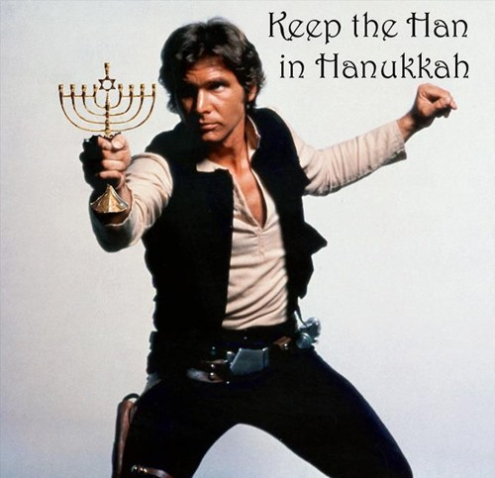

The Vilna Gaon comments that in order to understand any concept, one should look at the first time that word/concept appear in the Torah (for that is the equivalent at looking at the concept’s genes). So where does hoda’ah first appear in the Torah? Well, thankfully we do not have to search from the beginning of the Torah onwards, for the Gemara tells us the answer. Berachot 7b reports that Rav Shimon Bar Yochai taught that the first person to give what we call ‘hoda’ah’ to HaShem was Leah, when she said (Bereishit 29;35) upon giving birth to her 4th son Yehudah ‘this time I thank (odeh) HaShem.’ Rashi explains why this time; since Leah saw in ruach hakodesh that Yaakov’s four wives would give birth to a total of 12 tribes. Naturally, she assumed that each would give birth to three children. Once she had a fourth child, she saw that she had got more than she ought to have been given, and thanked HaShem. Putting all this together, hoda’ah is therefore the recognition that once got more than they seemingly deserved/thought they were entitled to. [see above page 10-11]

One can thus start to see why hoda’ah is so central to our Jewish lives. Firstly, it is a basic recognition of ‘thanks’ and realization of the Source of things; in reflection of this, modeh means both ‘thanks’ and ‘admission,’ for when one thanks another, they are admitting that the other gave them something/did something for them. And at a greater level, hoda’ah is an admission that everything ultimately comes from HaShem, and so He can remove or withhold anything from us; more or less everything could be seen as more than expected and thus deserving of hoda’ah (see the berachah of asher yatzar for example).

Why is hoda’ah most pertinent to Hanukah of all times?

Didn’t HaShem give us more on Pesach when he brought us out from slavery, or on Shavuot when the Torah was to be given?

Our answer begins with the Chofetz Chaim in his Mishna Berurah (670;6). He explains that the reason why there is no festive meal on Hanukah, unlike Purim, is that since the battle on Purim was for our physical survival (Haman wanted to kill us all), we celebrate via more physical things e.g. seudah. In Hanukah, however, the Greeks did not want to kill us; they waged war against our spiritual observance, and so no seudah is stipulated. Rather, the days of Hanukah were fixed for hallel and hoda’ah since He brought this spiritual victory. However, this itself perhaps needs a fuller explanation; if the point is that on Hanukah our victory was a spiritual lift, not a physical savior, then why isn’t Pesach the festival of hoda’ah?

On Pesach HaShem lifted us from the penultimate level of tumah to being on the way to receiving the Torah (a much greater spiritual jump than Hanukah) via unmatched open revelations and miracles. Wouldn’t Pesach be more appropriate for to stress hoda’ah? To answer this, let’s be very Jewish and ask another question. On Purim, we were threatened with physical annihilation and our response was to fast and pray; not to wage war. On Hanukah, when the threat was a spiritual one, we rose up and took arms to fight the Greeks. Why does there seem to be this dichotomy? The answer here is the dictum hakol biydei shamayim chutz miyirat shamayim. (lit. everything is in HaShem’s Hands apart from your fear of Heaven) This means that while one’s physical possessions, incomes, occurrences etc are planned from HaShem, one’s spiritual work is not planned/controlled by HaShem (at least in the same way.) in order to facilitate freewill. Consequently, when the threat on Hanukah was a spiritual one, we had to take matters into our own hands, and we fought. On Purim, however, when the threat was a physical one, we handed it over to HaShem via davening and fasting (R Tatz.) And Pesach is the same as Purim in that the Egyptians’ main attack against us was physical (/economic); spiritual demise was a consequence.

Now, in having to get up and fight in Hanukah (for it was a spiritual attack against us), there lies a potential pitfall. One might have thought that since we got up and fought, then the victory was all down to us. After all, it was a war ranging many years with casualties; we won and got what we deserved. Thus, chazal fixed this festival as one of hoda’ah to teach us that even when it might seem that we got what we deserved because of us, it was HaShem who brought our victory and we did get much more than one would expect to deserve. This would also explain why Rashi says that Hanukah’s reflection of hoda’ah is the al hanissim prayer; for this talks predominantly about the miracle of the victory in battle as opposed to the miracle of the oil. And according to what we have said, the hoda’ah was mainly fixed for the war miracle; the miracle of the oil lasting was openly supernatural. [There is hoda’ah for that too; see Rambam Hanukah 4;12.] In other words, Hanukah teaches us that hoda’ah is not only for the big open miracles, but for achievements that one might think were due to themselves too. This is taught by Rachel Imeinu too; her hoda’ah for giving birth to Yosef, her first child, was that ‘now if I break a pot at home, I can blame it on my child’ (Rashi Bereisheet 30;23). Is this really all she was grateful for; after having no children for so long, this is all there is to be grateful about? The answer is that Rachel was even grateful for this small thing; and of course everything else too. Again, the point is that hoda’ah embraces all parts of life.

Perhaps this is something to think about when, in Aleinu 3 times a day, we say that, we are mishtachavim and modim to HaShem. [see below pp. 37-40] Or noticing to say thank you to the many people who do us favors without our even realizing (people who set up kiddish, baal koreh, security guard, school/shul board,etc).

This Thanksgiving’s Spiritual Benefits

Our Rabbis teach us that the final sealing of the judgment that begins on Rosh HaShanah actually occurs on this Thanksgiving, the days of Hanukah, the Holy days of Hod, of thanksgiving. The Maggid of Koznitz explained the verse, “For it is a statute for Israel, the judgment of the G-d of Ya’akov .” (Tehilim 81:5), as referring to the attempts by the evil inclination to drive a wedge between the people of Israel and G-d. Thus, G-d proclaims that it is a statute carved in stone that, by law, G-d is the G-d of the sons of Ya’akov. On Hanukah, G-d is once again revealed as the “G-d of Ya’akov and he wishes us a Gemar Hatima Tovah. HaRav Avraham of Slonim, the author of Beit Avraham, comments:

“From the straits I called G-d; G-d answered me with a vast expanse במרחב ” (Tehilim 118:5). The “straits” are the High Holy Days of judgment, but the vast expanse, במרחב , is Hanukah. The gematria of במרחב is בנר , literally, with a candle, hinting at Hanukah. Thus, even when we are “lower than 10 handbreadths” in dire straits, we are still thought of by G-d as “who is like Your people Israel, one nation in the land!?”

Eight Qualities of “Hod”—ing

We intend to meditate on 8 “senses” of Hod during the Eight Days of Thanksgiving:

1. Hodaya as thanksgiving appropriate for Thanksgiving Day, Wednesday-Thursday nights. (p. 19)

2. Yehudi--Jew--Yehuda, Yehudit : for the Second Night of Thanksgiving, Thursday-Friday night. (p. 22)

3. Hoda'ah as acknowledgment for Shabbat, as we say in our prayers: A Song, a Psalm for the Shabbat Day: לַיהוָה לְהֹדוֹת טוֹב It is good to acknowledge Hashem… (p. 26)

4. Vidui as confession for the Fourth Night of Thanksgiving, from Saturday to Sunday nights, as we move into realities of 24/6, taking account. (p. 28)

5. Hed as splendor, reverberation and glory, as we stare into the glowing illumination of the candles, for the Fifth Night of Thanksgiving. Charity/gelt is also traditionally given on this night, which can never fall on Shabbat. (p. 31)

6. Hod as majesty and an elevation of the bestower. R. Avigador Miller (z’l) holds when you have cause to thank someone, you do not discharge your obligation by simply muttering a couple of words; you need to work on recognizing and studying the virtue of that benefactor--to elevate him and give him majesty (Hod). The Aleinu prayer helps us to recognize this on the Sixth Night of Thanksgiving. (p. 35)

7. Hod as empowering. Here Rabbi Yitzchak Schwartz of Jerusalem leads us on a guided meditation focusing on Hod as “enabling” and empowering for the Seventh Night. (p. 41)

8. Hod as modesty, humility. We conclude “at the bottom”, with R. Simon Jacobsen’s masterful treatment of Hod as signifying humility. (p. 43)

On the First Night of Hanukah/Thanksgiving, THE TRUE LOVE gave to me:

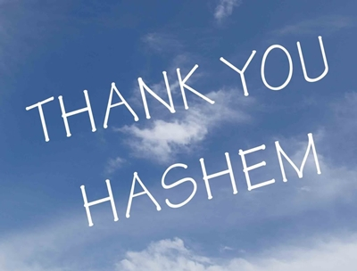
We light candles on Wednesday night, November 27th, the first night of Hanukah.

Since the majority of Americans eat their Thanksgiving meal at 3:00 p.m. on Thursday, it would seem appropriate to meditate on the concept of a seudat hodaya—a meal of thanksgiving—tonight and tomorrow. For those readers who neither live in the States nor celebrate Thanksgiving, the concept of seudat hodaya is worthy of contemplation, given its root of Hod, the main expression of Hanukah as described above.

The Jewish custom is to make a seudat hodaya (meal of thanksgiving) following recovery from a serious illness or surgery. Here are some of the Torah and halachic sources for this custom

One of the korbanot the Torah describes is a Korban Todah (sacrifice of thanksgiving) (Vayikra 7:12). However, the Torah does not say when one offers it. The Gemara (Berachot 54b), in the context of Birkat Hagomel (blessing after surviving dangerous situations), says that the "survivors" of four situations have to give thanks: a voyage at sea, traversal of the desert, illness, and captivity. The Gemara demonstrates how each of these situations is described in Tehillim 107, the mizmor that deals with thanks after being saved from difficult situations. Even at the time of the Beit Hamikdash, it appears that people such as these were not obligated to bring a Korban Todah. Rather those are among the appropriate situations to volunteer one (see Rashi, Vayikra 7:12 and a thorough presentation in Nishmat Avraham, Orach Chayim 219:1).

Eating is a major element of the Korban Todah. This korban included 40 loaves of meal-offering, 36 of which were to be eaten. The Abarbanel and the Netziv (both on Vayikra 7) famously explain that the Torah required a lot of eating in a short amount of time to encourage the thankful person to bring together many people where he would hopefully give proper public thanks to Hashem.

What do we do without a Beit Hamikdash to bring a Korban Todah? The Rosh (Berachot 9:3) and the Tur (OC 219) say that Birkat Hagomel was instituted in place of the Korban Todah. While the simple reading is that Hagomel is an obligatory beracha, the Magen Avraham (beginning of 219; Pri Megadim, ad loc. disagrees) suggests that it might be optional. In any case, it provides a defined opportunity to thank Hashem publicly (it must be recited before a minyan, preferably including two distinguished people- Shulchan Aruch, OC 219:3).

Whether or not the Korban Todah or Birkat Hagomel is obligatory, a seudat hodaya for being saved from dangerous illness is certainly not obligatory. This may explain its absence from explicit discussion in most classical works (including the Shulchan Aruch). However, significant sources provide precedent and support for the idea of doing something more than saying Hagomel, including a seuda. The Mishna Berura (218:32, in the name of "Acharonim") says that one who was saved from possible death (apparently even if the salvation was natural) should do the following. He should set aside money for tzedaka and say that he wants it to be considered as if he spent the money on a Korban Todah, donate things that help the public, and on every anniversary find a special setting to thank Hashem, be happy, and tell His praises. Certainly, a seudat hodaya is an appropriate setting for it, but it is not part of a set formula.

The Gemara (Berachot 46a) tells that when Rabbi Zeira was sick, Rabbi Avahu promised that if he recovered, Rabbi Avahu would make a festive meal for the rabbis, which, Baruch Hashem, occurred. Some say that not just the meal but the promise to make it is significant, as the promise of such an event if the sick person recovers is a segula (good omen) for the recovery (see Gilyonei Ephrayim, ad loc.). This would evidently only work if the seuda of that nature is desirable. The Chavot Yair (70; see also Pri Megadim, Mishbetzot Zahav 444:9) in discussing different meals that are a seudat mitzvat, mentions the seuda after being saved from danger. While some seudot mitzvah are obligatory, many are not but are positive ways to give prominence to noteworthy events.

Rav S.Z. Auerbach explained (see Mizmor L’todah (Travis) p. 185) that by eating in the context of thanksgiving to Hashem one expresses the following idea:

A person should know and show that the goal of life and the physical world that he is enjoying after his recovery is to serve as a medium through which to further his spiritual life and give thanks to Hashem.

MEDITATION FOR TONIGHT AND FOR THE THANKSGIVING MEAL

We should meditate on Mizmor Letodah, the Psalm of thanksgiving, Tehillim 100.

Mizmor Letodah A song for a thanksgiving offering. Shout to Hashem all the earth.
Serve Hashem with joy, come before Him with praise
Know that Hashem is G-d; He made us and we are His, people and the flock of His pasture.

Come into His gates with thanksgiving, [into] His courtyards with praise; give thanks to Him, bless His name.
For Hashem is good; His kindness is forever, and until generation after generation is His faith.

Avudarham notes that the Name of G-d is mentioned 4 times in this psalm, representing the 4 types of people who are required to bring a thanksgiving offering to G-d:

- One who is freed from imprisonment;
- One who is cured of a serious illness;
- One who safely crosses the sea; and
- One who safely crosses the desert.

The acronym of these instances is Chayim—life:

- Chet is from Chavush BiVait Ha’asurim—one who has been jailed in prison.
- Yud is from Yisurim—illness (or suffering);
- Yud is from Yam—sea; and
- Mem is from Midbar--desert

This idea is also conveyed by the words in the Amidah, the Modim prayer of thanksgiving:

סֶּלָה יודוּךָ הַחַיִּים וְכָל

“All the living (Chayim) shall give thanks to You, Selah!”

Although this psalm represents only these 4 people, it is recited by all praying the morning service as a reminder that miracles happen to us daily—even though we may not be aware of them—and we must thank G-d for them. (Siddur of Rav Yaakov Emden).

So on either Wednesday night or at your Thanksgiving meal Thursday afternoon, contemplate either by yourself or with others around the table, the daily miracles we are blessed with, things we may take for granted. Make your meal—perhaps your Thanksgiving Feast—a true seuda hodaya, a meal of thanksgiving, in solemn recognition of all we receive each blessed day.

On the Second Night of Hanukah/Thanksgiving, THE TRUE LOVE gave to me:

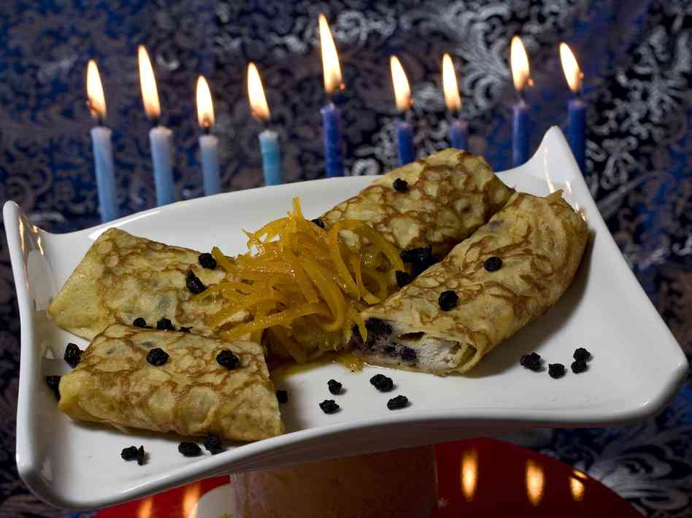

Lemon and dried blueberry blintzes, filled with creamy ricotta cheese, provide a tasty way to serve dairy and honor Yehudit/Judith for Hanukah

There is a custom to eat cheese on Hanukah. Rema on Shulchan Aruch OC 670.2 holds:

There are those who recommend eating cheese on Hanukah since the miracle came about through the milk that Yehudit fed the enemy.

The Mishna Berurah adds:

She was the daughter of Yochanan the High Priest. At that time there as an evil decree that any women who got engaged was to first sleep with the royal dignitary. She fed him cheese to make him tired and then chopped off his head. Then they all fled.

Who was this Yehudit/Judith?
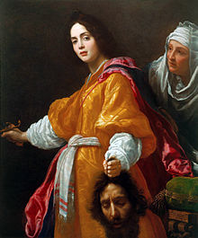
Yehudit was said to be a beautiful widow who lived in the town of Bethulia in Israel during the sixth century B.C. An army set siege on the town, and Yehudit went into the enemy camp to meet with their leader, Holofernes, a general for Nebuchadnezzar, king of the Assyrians. Holofernes was so charmed by the widow that he drank too much wine and passed out, after which Yehudit took his sword and cut off his head. The severed head inspired the Israelites to attack, and the Assyrians fled.

Yehudit didn't make it into the Tanakh, the canon of Jewish scripture that includes the Torah. By the Middle Ages, though, Jews were telling a Yehudit tale. Susan Weingarten, a scholar of Talmudic food in Israel and a contributor to the book The Sword of Judith, opined that it could be Jews were taking back their Jewish heroine,
By that time, the story of Yehudit had become associated with Hanukkah, despite her story occurring centuries before that holiday miracle of the oil was thought to take place. In Jewish versions of the story, passed down orally through the centuries, It could be Jews were taking back their Jewish heroine, often became the aunt or daughter of Yehuda Maccabee, the hero of the Hanukkah oil story. Her addition may have served as a parallel to that of Esther, who saves the Jewish people from a death order in Persia and is the heroine of the spring holiday Purim.

The Jewish tales of Yehudit also made their heroine clever. In the original story Yehudit
brought what Weingarten calls a "doggie bag" of food with her to Holofernes' camp — items like dry fig cake and bread — so that she wouldn't have to eat the food of the enemy king. But in some of the Jewish stories, she shared her food with the general. And there was a salty item guaranteed to make her enemy thirsty enough to get drunk; that was cheese. One version of the story specifies that the cheese was cooked into a pancake.

This is Reb Shlomo’s version, the story of Holy Sister Yehudit:

The Greeks had a law that when a Jewish woman got married she had to spend the first night with Greek soldier. The Greeks couldn’t stand the holiness of the Jewish homes. They wanted to tear out the holiness which is the foundation of Israel. So what happened? People either got married secretly, or they were afraid to get married at all. Finally Yehudit, the sister of Yehuda Maccabee, was supposed to got married. Thev wanted to marry secretly, but even if the wedding was secret, they still had to be prepared, because, G-d forbid, something might happen. It was especially hard to keep Yehudit’s wedding secret because her father was the Cohein Gadol, the High Priest, and word got around that the High Priest’s daughter was getting married. In the middle of the wedding the Greek soldiers come to take her away. They saw the Greeks coming, and, since they were just a little family and a few friends, they were afraid and everyone wanted to run away. Yehudit was dressed in her bridal garments, but suddenly she lifted her dress and showed everyone that she was dressed in armor underneath. She took a sword and a shield, and said, “I’m going to protect myself. I’m sorry that my brothers are cowards, but I’m not.” Suddenly, Yehuda Maccabee realized, “Why am I such a coward that I can’t protect my own sister?” When the Greeks came they thought they could take away the bride and that’s it. They weren’t even prepared to fight. Yehudit was very beautiful, and the top Greek officer had been celebrating all day in anticipation, but when he came to steal Yehudit away, Yehuda Maccabee took out his sword and knocked his head off in one second! All the Greeks ran away. It all started because of Yehudit’s courage.

How does this relate to the Hod aspect of Hanukah we are expounding?

The answer: Mamash-exactly!

Our heroine is Yehudit, sister of Yehuda Maccabbee.

Both of their names have the root Hod. We discussed how Leah named Yehuda:

"She conceived again and bore a son, and declared, 'This time, I will gratefully praise [odeh] Hashem;' therefore, she called his name, Yehudah..."

Yehudit is the female version of the name Yehuda, both related to the word Hod.

MEDITATION FOR TONIGHT

The Greeks attempted to disrupt Jewish life by issuing a ban against the three institutions of חֹדֶשׁ Kiddush HaHodesh (maintaining the Jewish calendar based on the lunar cycle), שַּׁבָּת Shabbat, and מִילָה Berit Milah (circumcision). This attempt was focused at the "heart" of Jewish practice, at our way to bring Hashem into our lives. The Netivot Shalom writes that we are always bringing Hashem into our lives. The Greeks could not fathom that. They would not mind if a Jew fasted, they did not want us to associate our gashmiut with kedusha. For this reason they forbade us to keep Shabbat, Berit Milah and Hodesh. Shabbat involves much gashmiut, as we have learned – oneg Shabbat etc. but we are to turn it towards Hashem. Berit Milah is a sign that we curb our desires and use them for Hashem’s mitzvot and רצון . Hodesh is our connection, our Emunah that even though we might almost disappear like the moon, our love for Hashem and His love for us will always have us grow and shine.

The Greeks therefore tried to eliminate 3 of our most important spiritualy powerful connections to Hashem.

The Ben Ish Hai writes that the first letter of the word חֹדֶשׁ Hodesh (month) is חֹ Heit, the second letter of the word שַּׁבָּת Shabbat is בָּ Bet, and the third letter of the word מִילָה Milah is לָ Lammed.

The three letters spell the word חָלָב Halav/milk, and therefore the custom developed to eat dairy products like cheese on Hanukah.

Tonight—Thursday night—perhaps blow off eating turkey, saving it for the Holy Shabbat on tomorrow Friday night, where a meat meal is recommended. Eat cheese dishes, and meditate on your gratitude toward Hashem for our Shabbat, our calendar, and our Covenant. Acknowledge the roles that Jewish heroines and heroes—like your ancestors who fought brave battles for your survival—have played in bringing you to this moment, celebrating Hanukah in freedom without fear of reprisal.

On the Third Night of Hanukah/Thanksgiving, THE TRUE LOVE gave to me:
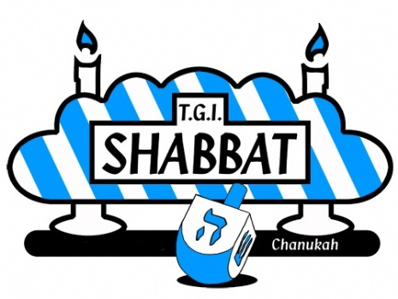
Hoda'ah acknowledgment for Shabbat, as we say in our prayers: A Song, a Psalm for the Shabbat Day: לַיהוָה לְהֹדוֹת טוֹב It is good to acknowledge Hashem…

Today is Shabbat Hanukah, when Torah and Rabbinic Holy Days converge.

Be careful to light the Hanukah lights first, which is tricky with the early sunset times. That’s because if we light Shabbat candles first, it’s then Shabbat, and we may not make any fire after. [Igrot Moshe O.C. 4:62]

The Psalm for Shabbat begins as mentioned above: it is good to acknowledge Hashem.

See, everything depends upon Shabbat. It is worth noting that the days of the week have no names in the Hebrew language. They are counted as Yom rishon b’Shabbat, “the first day towards the Shabbat, “Yom sheni b’Shabbat, “the second day towards Shabbat” and so on until Friday, also called Erev Shabbat, the eve of Shabbat, and then Shabbat. The Shabbat permeates every day of the week, and Kabbalah sees the days of the week as “branches” while the “roots” are in the Shabbat.

Thus, once the 24/6 live takes the pause which refreshes, “it is good to acknowledge Hashem” on this day of ceasing, rest, of Shabbat.

Midrash Socher Tov gives over that Moshe Rabbenu dedicated this psalm to the tribe of Yehuda, named by his mother Leah “Hapaam Odeh et Hashem/this time let me gratefully acknowledge Hashem.”

On Shabbat, it is particularly good to acknowledge Hashem. For during the week, we are preoccupied with the necessary but mundane pursuits which prevent us from concentrating on G-d’s wonders. But on our day of rest, our soul is liberated from its weekday bindings. Cleansed and purified, our soul can meditate upon the wonders of G-d’s providence and His system of reward and punishment, as explained by Radak, Meiri, and Rashbam.

As a heads up to tomorrow night’s meditation, some also translate לְהֹדוֹת as “to confess.” When Adam Rishon did teshuva for his sin, he composed this Psalm to teach all future generation that “it is good to confess to Hashem” in order to achieve atonement and to be be saved from Gehinnom, as given over in Pirke D’Rabbi Eliezer 19.

MEDITATION FOR TONIGHT:

My wife a few years ago read that happy people regularly acknowledge those things they are thankful for, some keeping a “gratitude journal”. We see this ritually around the Thanksgiving Table; many of us observed this yesterday. Our house is blessed to do this nightly. And it is important family bonding time.

Tonight, at your Shabbat meal, perhaps while the Hanukah candles are still blazing, acknowledge some of the wonders in your life, those G-d given gifts that you appreciate Health, love, life, home, warmth, food, clothing, etc.

On the Fourth Night of Hanukah/Thanksgiving, THE TRUE LOVE gave to me:

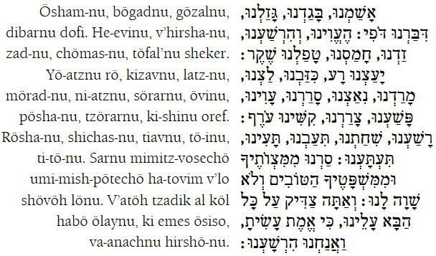

Viddui confession is our form of Hod for the Fourth Night of Thanksgiving, from Saturday to Sunday nights, as we move into realities of 24/6, taking account of our deeds, words, and thoughts. Now during Hanukah, tachanun/supplication is an inappropriate accompaniment to days of joy. (Rambam, Laws of Prayer 5:15) But vidui, with root Hod, is an important part of acknowledgment, recognizing where one has missed the mark. And since we have learned that Hanukah is our “final” time to fix the miss-takes of this year, contemplating viddui seems in order at this juncture.

In Jewish practice, a penitent sinner must give verbal expression to his remorse: He must confess his sin before G-d pardons him. Strictly speaking, the confession is acceptable even in the bare formulation: "I have sinned," but more elaborate forms have been compiled and used. Rambam (Teshuvah, ch.1‑2) holds that the more the sinner confesses at length the better, but gives as the basic form: "O G-d! I have sinned, I have committed iniquity, I have transgressed before Thee by doing such‑and‑such. Behold now I am sorry for what I have done and am ashamed and I shall never do it again."

In Judaism confession is to G-d alone not to a priest, as in Catholicism, and although it is true that, on the whole, the Jewish teachers frown on public confession as brazen (Berakhot 34b), it is incorrect to say that confession of sin addressed to another human being is entirely unknown in any form of Jewish observance.

In the Sefer Hasidim, the idea is found of confessing sins to a spiritual mentor, a 'father confessor,' who would give the sinner a penance to perform. The Sefer Hasidim is fully aware that the Talmud does frown on confession to others, but holds that this does not apply where the confession is made to a discreet sage who can be relied upon not to publish the sin abroad and who can instruct the sinner how to do penance for his particular sins so that he may inherit eternal life. In some versions of Hasidism, too, confession to a mentor, in this case the Hasidic master, the tzaddik, is advocated.

The Hasidic master Elimelech of Lizansk (1717‑87) writes, in his list of spiritual counsels:

"A man should tell his mentor who teaches him G-d's way, or even a trustworthy friend, all the evil thoughts he has which are in opposition to our holy Torah, which the evil inclination brings into his head and heart, whether while he is studying the Torah or offering his prayers or when he lies on his bed or at any time during the day. He should conceal nothing out of shame. The result of speaking of these matters, thus actualizing the potential, will be to break the hold over him of the evil inclination so that it will possess less power to entice him on future occasions, quite apart from the sound spiritual guidance, which is the way of the Lord, he will receive from his friend. This is a marvelous antidote to the evil inclination."

Another Hasidic master, Rebbe Nachman of Bratslav (1772‑1811), in his anthology of spiritual maxims, Sefer Ha‑Middot, writes: "Good thoughts are the result of confession of sin to scholars."

Confession of sin is an integral part of the Yom Kippur liturgy. At various stages during the service of this great Day of Atonement, a standard confession is repeated by the cantor and the congregation, in some congregations accompanied by a joyous melody. As the Baal Shem Tov [the founder of Hasidic Judaism] is reported to have put it: "The charlady who cleanses from their dirt the floors of the king's palace, sings sweetly as she works.”

Originally confession was left to the individual to give expression in his own way to his inner hurt. But eventually a formal confession was introduced in which a variety of sins are mentioned in alphabetical order. Does this, however, not frustrate the whole purpose of confession when it is turned into a purely mechanical act devoid of inwardness? Perhaps before the days of printed prayer books, the alphabetical form was an aid to memory. Also when the whole congregation adopts the same form of confession, the individual is spared the embarrassment he might have suffered if his particular listing of his sins were to be overheard. In this connection the Talmudic saying is quoted that, in Temple times, the sin‑offering was slaughtered in the same place as the burnt offering in order not to expose the sinner to public shame. The individual is encouraged, however, to think of his or her particular sins while reciting the standard confession with the congregation.

MEDITATION FOR TONIGHT:

It is always important to take a personal accounting.

The half-hour after the candles have been lit is a perfect time to do so. It is Saturday night, motzai-Shabbat, so there is probably nothing too pressing right now.

While the candles are burning, bring a notebook and a timer or alarm clock. On a blank piece of paper write: “Is there anything in my behavior or thoughts that is now distorting or diminishing what is holy in me?” Close the notebook and put it away. Set the alarm for five to fifteen minutes. During that time, sit quietly, breathe deeply, stare at the candles, and see what comes up. If you become distracted, return your focus either to your breath or to the question. When the alarm sounds (and only then), stop gazing at the candles and make some notes about how you felt and/or any specific thoughts that you remember. Even if you didn’t “get an answer” or even if you forget some insights you had, the question has planted a seed, and it will bear good fruit.

On the Fifth Night of Hanukah/Thanksgiving, THE TRUE LOVE gave to me:

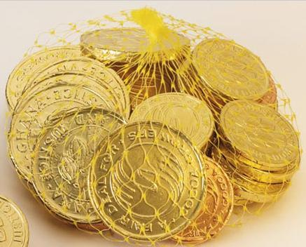

Hod as הֵד Hed/echo
Rabbi Yitzchok Ginsburgh reveals the sense of Hod called הֵד Hed, meaning echo, and connoting splendor, reverberation and glory. Tonight we meditate on the echo in our lives.

An echo is a sound or series of sounds caused by the reflection of sound waves from a surface back to the listener, as in "the walls threw back the echoes of his footsteps."

Tonight is the fifth night of Hanukah. On that day, it is customary to make special increases in good matters over and above the practices connected with the other days of Hanukah; good matters need to “reverberate” on this night. For example, the Rebbe Rashab of Chabad would give Hanukah gelt on the fifth (or at times the fourth) candle of Hanukah. The fifth night can never fall on Shabbat, and its weekday status itself is an echo of the holiness of the Holy Shabbat. Chocolate gelt is an “echo” of real money, and the images of real money are a sort of pictorial reflection of live images.

Specifically, echo relates to sound. A question for us is does Hashem still speak with us; can one really receive a direct communication from Hashem? After all, if Bilam’s donkey can get a direct link to Hashem why can't an ordinary Jew? This question is posed by Rav Tzadok HaKohen in his sefer Pri Tzadik. Bilam's donkey had quite a mouth. Our sages teach us that its mouth was created during the twilight period between erev Shabbat and Shabbat night (Avot 5:6).
Rav Tzadok haKohen, in a marvelous exposition, points out that there are two types of speech that a human being possesses. The first one is what Hashem bestowed upon man the day he was created. The second type was created on Shabbat itself. "On Shabbat Hashem created the mouth that is above all other mouths…the mouth of Hashem was created on Shabbat, the other mouths (those of the land, the well, and the donkey) were created during the twilight of erev Shabbat" (Zohar vol. 3 p. 201b). On Shabbat man was given the ability to speak the words of Hashem. This is not merely the physical speech but rather the ability of the neshamah to speak the actual words of Hashem. Through this form of speech the words that come out of our mouths are not just a repetition of Hashem's words but an echo of Hashem's voice that penetrates the depths of our neshamah.

A profound concept, indeed. That when we speak Hashem’s words, they are an echo of His Voice, infusing our souls.

This links to R. Soloveitchik’s teaching on Anochi Hashem Elokecha, G-d first words of the 10 Commandments—“I am Hashem your G-d”:

The echo of Hashem’s voice reverberated throughout the world and seemed to come from every direction. Rashi explains that “Anochi” reinforced the idea that there is only one Hashem that is the source of all of those voices, not multiple beings.

The hearing of an echo reminds me of the primary event on Rosh Hashanah day-- the sounding of the shofar. There are many halachot in the Shulchan Aruch concerning the shofar itself, the sounds produced, and the individual who hears it. One of the halachot is that it is obligatory to hear the actual sound of the shofar and not an echo. If one hears the echo of the sounds of the shofar, he has not fulfilled the mitzvah. One may wonder why the Sages were so insisting that the actual sound be heard. After all, the echo sounds exactly the same as the original sounds and, it is in fact a reflection of the original.

The Midrash Rabbah (Shemot 28:6) states that at Mount Sinai when Hashem gave the Torah to the Jewish people His voice was unique in that it had no echo. Usually, the stronger the voice, the stronger the echo. Isn't the lack of echo from Hashem's voice a sign of weakness?

The distance the voice can travel depends on the strength of the person. When the voice reaches a wall, it rebounds, causing an echo. The Midrash is implying that the voice of Hashem was so powerful that it penetrated and permeated every person and every physical part of the universe so that there was no echo.
The Rambam (Teshuvah 3:4) writes,

"Although the blowing of the shofar on Rosh Hashanah is an unexplained Scriptural command, it contains an allusion: 'Sleepers, awaken from your sleep and you that slumber awake from your slumber, and ponder your deeds, remember your Creator, and go back to Him in penitence. You who miss the truth in your pursuit of vanities, and waste your years in seeking after vain things that can neither profit nor deliver, look after your own souls, and improve your ways and your deeds. Let everyone of you abandon his evil ways and thoughts and return to G-d that He may have mercy on you' "

Everyday a bat kol emanates from Mount Chorev and declares, "Woe to them, to the people, because of their insult to the Torah" (Pirkei Avot 6:2). The commentaries explain that the giving of the Torah did not stop, as it says, "A great sound that did not cease" (Devarim 5:19). One with an attuned ear hears the voice of Hashem giving the Torah continually, as the basis of all of creation.

When the voice is not heard, then the bat kol (echo) goes out proclaiming the disgrace to Torah.

The halachah of hearing an echo is imparting a very important message.

The sound of the shofar is supposed to permeate us and move us to change and reach for higher goals and aspirations. "Hearing an echo" means that the sound of the shofar instead of permeating the person, has hit him on the outside and has bounced off not making any inroads into the person himself. Such a person, though he has come to Shul and though he has heard shofar sounds, has not really achieved the true intention of the mitzvah of hearing shofar.

Rebbe Nachman of Breslov also has questions about the hearing of an echo. In his famous story of the Seven Beggars, on the 2nd day, the beggar was deaf, but still managed to teach that all sounds come from deficiencies, since everyone cries out because of what he is lacking [chasronot]. All worldly sounds are an echo of the True Voice [ L.M. II 23] This echo is source of all deficiencies in the world. It is the sound of worldly foolishness that results from tzimtzum constriction.

The Torah, on the other hand, is the direct sound that was the power of all creation. An echo is a direct sound that hit a barrier and is reflected. In the original tzimtzum, there was a thin line of Light that entered the Vacated Space. This was the light of the Torah. It struck the central point and produced the reflected light, the echo.

The ring of Light was the direct voice with which all things were created, as is written, “With G-d’s Word the heavens were made.” (Tehillim 33:6) When this voice hits the central point, which is the final barrier of the tzimtzum, it creates an echo. This is so much like the direct Voice, that one can be mistaken and think it to be the True Voice. This is the source of Free Will. [Likutey Halakhot , Even HaEZer, P’ru uR’vu 3:32]

This echo, according to Rebbe Nachman, is lacking in Divine Power and good. Since this echo is the source of all worldy sounds, they are not holy, they have some worldly desire in them. [Id. at 3:34]

So what is it?! http://www.youtube.com/watch?v=GXWcqriPvgk

Is an echo a tainting of the True Voice?

Do we speak Hashem’s words, the echo, and permeate our souls?

This is the work for tonight.

MEDITATION FOR TONIGHT
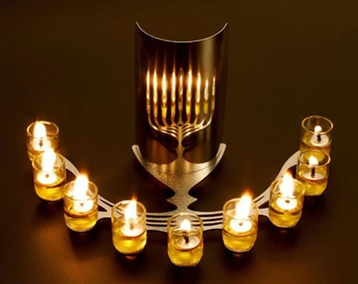
Sit in front of the candles and feel the direct light flowing on to you. Imagine now that this light has sound. What does this sound, sound like? Is it musical, is it melodic, does it have a nice beat, can you dance to it? Now, can you perceive “words” from this light? If so, next contemplate your response, your הֵד reverberation, your echo, the returning light, your arousal from below to above, Or Chozer. What does that sound like, look like, smell like, feel like, taste like? What is your inner Torah telling you about the good matters, words, and thoughts you need to increase during Hanukah?

On the Sixth Night of Hanukah/Thanksgiving, THE TRUE LOVE gave to me:

G-d’s Majesty through עָלֵינוּ

Hod has a sense of majesty. When I think of majesty, I think of “America the Beautiful”, and purple mountain’s majesty: http://www.youtube.com/watch?v=GX7BcixX-4U
Not of “Her Royal Majesty”:

But rather of the grandeur, greatness, the lofty, or stately dignity; imposing character, of G-d. Anyone who has been blessed to see mountains in their natural environment can attest to physical grandeur: “experience the majesty of the Rockies."

Spiritual majesty, all the more so.

There is a prayer said thrice daily which seeks to emphasis the majesty of G-d: עָלֵינוּ the Aleinu.

According to the sages, Yehoshua/Joshua composed this prayer upon entering the Holy Land. The great Kabbalist, Rabbi Yitzchak Luria, the Arizal, writes that this prayer contains within it greater praise then the entire prayer service.

Aleinu secures the prayers so that none of the energy of our prayers become a source of anything unholy. For example, our elevated rapture does not evolve into anger.

Aleinu is more than prayer, as it also serves to help smooth the transition between prayer and our movement outward into the world. It assists us in rejoining the world, and that is why it is said at the end before we leave the synagogue.

Concluding prayers, we journey into the world with the recognition that “there is nothing else” besides Him. Realizing this allows us to see the hand of the Creator in every step we take, and as a result, our lives become more G-dly and less mundane, more spiritual and less materialistic, and more profound and less petty.

For many years, this prayer has been the concluding prayer of all the services. One reason for this is that during our prayer we have asked for the downfall of the wicked. We therefore conclude with two requests (a) to see the majesty of the Almighty, and (b) that G-d should not destroy sinners, rather their sin; wicked people are also creations of G-d, and even they have a chance to repent and become righteous.

It is the former request which we shall contemplate tonight.

So great is the importance of Aleinu, Jewish law requires that when it is recited in the synagogue everyone present should join in, even one who has already said it, or one who just walked into the synagogue.

In this prayer, we explicitly say:

“But we …uModim offer praise, before the supreme King of kings, the Holy One blessed be He...”

הוּא בָּרוּךְ הַקָּדושׁ הַמְּלָכִים מַלְכֵי מֶלֶךְ לִפְנֵי וּמודִים … וַאֲנַחְנוּ

Let us examine some of the praises of G-d’s majesty found in Aleinu.

It is our duty to praise the master of all things,

The word לַאֲדון "Ladon" (master) comes from the Hebrew word Adnos (to change). One has the ability to change ones nature, and to do the will of G-d, the Master of the world. All ability and strength in the world comes only from Him.

The Alter Rebbe said that Jewish physical matter is spiritual; G-d gives us material bounty so we can transform it into something spiritual. When, occasionally, G-d has not provided us with the material wealth, we must give G-d whatever we can - even a "pauper's offering," then He gives generously. We must praise G-d in order to receive in return,that is the importance of this prayer.

to exalt the Creator of all existence,

Our Rabbis, of blessed memory, teach us that the Jewish nation gives strength on high. Through our recognizing the majesty of G-d, and exalting His majesty, we cause the revelation of more of G-d's attributes, as stated L'cha Hashem HaGedulah, etc., ("To You, G-d, the greatness").This, then, is the reason behind creation to make goodness for all. When we recognize that G-d is the Creator, we recognize the majesty of G-d, and we reveal the true reason for which the world was created.

He has not made us like other nations of the world

The term "Asanu", (made), has the same root as the word Asiyah, and is said only regarding the Jewish nation. As it is written, "Like this said G-d," "made" comes from Vaya'as Elokim Et Harakieh, (G-d made the firmament), which comes from fixing and completing. This is similar to the way the Jewish nation wanted to be "fixed up" in order that they should be fit to receive the Torah. It is stated 'Israel, one nation on the earth." As the Alter Rebbe explains, "The nation of Israel, even in the earthly world, is bound up with the One G-d." G-d transforms the spiritual into something material; so too, Israel transforms the material into something spiritual.

nor caused us to be like the families of the earth;

The Eitz Yosef explains that the word "samanu" (caused) refers to the Torah and Mitzvot - G-d "caused" us to be with the Torah and not with the other nations. So one thanks G-d in this verse for two things: (a) for giving us a Jewish soul, and, (b) for giving us the Torah. While the previous verse is talking of nations in a general term, this verse speaks of families to indicate endearment and closeness to G-d.

that He has not assigned us a portion like theirs, nor a lot like that of their multitudes,

Our unique portion on earth is rooted in our unique relationship to G-d and to His Law. It is for this reason that our fate, too, is unique.

for they bow to vanity and nothingness

Some people have the custom of spitting after saying these words, to indicate that they do not wish to derive any benefit from idolatry and the like. The Arizal was very particular never to spit in a synagogue, just as he would not in his home.

But we bend the knee, bow down, and offer praise, before the supreme King of kings, the Holy One blessed be He.

Hakadosh Baruch Hu (The Holy One blessed be He) is a commonly used term among Jews with reference to G-d expressing His infinitely exalted majesty and at the same time His infinite and immediate nearness to all. He is infinitely exalted above all things, and yet He is also blessed. Every breath of ours should serve to advance the fulfillment of His purpose and symbolize our dedication to the realization of His will

Who stretches forth the heavens and establishes the earth, the seat of whose glory is in the heavens above

One should consider the following when saying, He who stretches out the heavens and establishes the earth. When one is reciting Eretz (earth - material matters), one should always look at one whose situation is lower than his. With regard to spiritual matters one should always look at the "Heaven" (Camay) - at He who is higher than oneself, and plead with G-d to grant him the intelligence to learn from the other and the ability and strength to rise higher

and the abode of whose majesty is in the loftiest heights. He is our G-d; there is none else.

He is the true source of strength, and continuously maintains Divine Providence, which only He can do. Some people add the letter Vav before Ein, (meaning there is no limit); others add the word Milvado (that G-d is infinite, as well as the only One).

What does there is none else mean? Moshe stated this, implying that everything, from the smallest particle of matter to the vast expanse of the cosmos, all continue to exist from moment to moment only because of G-d (even when the hand of G-d is evident to us indirectly, such as in birth and survival). There no alternative being we can trust or honor.

Truly, He is our King; there is nothing besides Him. it is written in His Torah “know this day and take unto your heart that Hashem is G-d; in the heavens above and upon the earth below there is nothing else.”

The Lubavitcher Rebbe writes in his notes on Tanya, in which the Alter Rebbe writes. "For would it occur to you that there is a god dwelling in the waters beneath the earth, that it is necessary to negate, if so strongly as to say take it unto your heart?" This verse continues the idea of an earlier verse, which begins with the phrase, "You have been shown...," which refers to the time at which the Torah was given. "At the time G-d spoke to you...," with a warning against worshiping any of the components of the created universe "Lest you become corrupt" and worship creatures of the lowest levels "any fish in the water below the earth,” or of the highest level, "Lest you raise your eyes heavenward."

As one looks at the majestic things that G-d created in the world, in the heaven above, and the earth below, one must ponder the wonders in the depths of the earth, and one must realize that there is none other than G-d in all worlds.

In sum, in this paen to G-d’s majesty, it is our responsibility to praise G-d, and proclaim Him the Creator of all existence. We are grateful that He has chosen us from among all the nations of the world to give us His Torah. Everything that exists, exists merely because of Him.

MEDITATION FOR TONIGHT

Say the Aleinu prayer with intention tonight, ideally from a traditional prayerbook which has the original words in Hebrew. Here is a good version:

http://www.chabad.org/library/siddur/default_cdo/aid/1495868/jewish/Siddur.htm#!/aid:1666780/title:Aleinu - שחרית לחול

Meditate on the images of G-d’s majesty invoked in this prayer. Contemplate how the majesty of G-d flows through your life. Seek ways to invoke this majesty on a regular basis, daily if possible through the Aleinu prayer. Gaze at the candles and imagine them to mirror the Menorah in the Temple, where G-d’s majesty shone over the entire world. Pledge to take some of this light and do the same, in the name of G-d.

On the Seventh Night of Hanukah/Thanksgiving, THE TRUE LOVE gave to me:

Hod as empowering

Rabbi Yitzchak Schwartz teaches that Hod relates to empowering, and when you examine closely to see how empowered or disempowered you and others are in every aspect of life, and how much of a difference it makes, then you realize that empowering yourself and others is perhaps one of the most primal of all human drives.

R. Yitzchak examines other definitions of Hod, and shows how the sense of empowering fits in:

‘DEVOTION’ : One who is motivated to empower, can be counted on to be very devoted constantly

‘ADORATION’ : A true empowerer is driven to do so, because they adore the one that they empower

‘SUBMISSION’ : As opposed to the Sefirat Netzach’s conquering domination, the Hod empower-er constantly has their sights on submitting themselves to Netzach’s empowering needs

‘GLORY’ : An empower-er sees to it that the other person shines---that the empowerment that has been lost becomes found until it manifests as true glory

‘RECIPROCAL RELATIONSHIP’ : When an empower-er steps into a relationship, they naturally elicit the other person’s response---a response that inspires them to elicit a response in turn

‘THE GID HANASHE’ [sciatic nerve] : Eisav’s Angel, though He lost the ‘wrestling match’ with Yaakov, nevertheless managed to leave Yaakov [the Jewish people ] partly damaged….the damage was to the sciatic nerve in the left leg –the part of the body that corresponds to Hod/empowerment….the damage that resulted was a lack of spiritual empowerment—the disability to stand up on one’s own feet , literally and financially , when it comes to matters of the spirit, such as Torah support.

MEDITATIONS FOR TONIGHT:

Here is Rabbi Schwartz’s Hod/empowering meditation, to be contemplated in front of the candles while burning on this Seventh Night of Hanukah:

AWARENESS OF DISEMPOWERMENT

-bring to mind an experience or situation in your life….

-ask yourself how empowered or powerless you are….

-on a scale of 1 to 10, how would you rate the experience….

-extend this to another experience and another until you begin to develop a sense of the level of empowerment that you are holding by presently in most all situations that you find yourself

RE-EMPOWERING OURSELVES

-begin to re-empower yourself by re-focusing on all the powerless experiences of your life….

-find something in or around the experience that you feel to be positive and that has redeeming value for you [including the realization that ultimately this experience is G-d sent and ultimately for your best]..

-focus on this to the exclusion of all the other negative aspects of the experience….

-if you still feel disempowered, then give it over to Hashem, expressing your need for Hashem to take over control [until ultimately you will be re-empowered]….

-do this [and any other type of re-empowering tool that comes to you] for another challenge in your life , and another and another, until you feel that you are beginning to experience a shift in your life….

RE-EMPOWERING OTHERS

-begin to shift the focus of attention in your re-empowerings from yourself to others, repeating all that you’ve done in the previous steps for yourself, and to do it instead for others…

RE-EMPOWERING THE PAST AND FUTURE

-begin to extend your empowerings to your past, by simply saying thank you for all of the empowerings that you have been given and that you have been allowed to give to others by the ONE ABOVE…

-keep repeating the” thank you’s” and let the memories come to mind, one by one…..
see how often that your and others powerlessness was replaced by empowerment, and be thankful for that, and for how often you and others you have helped, have been bestowed with empowerment in\your life…

-with this awareness, project a future of empowerment…

-a level of empowerment that’s beyond any level that you have ever experienced

On the Eighth Night of Hanukah/Thanksgiving, THE TRUE LOVE gave to me:

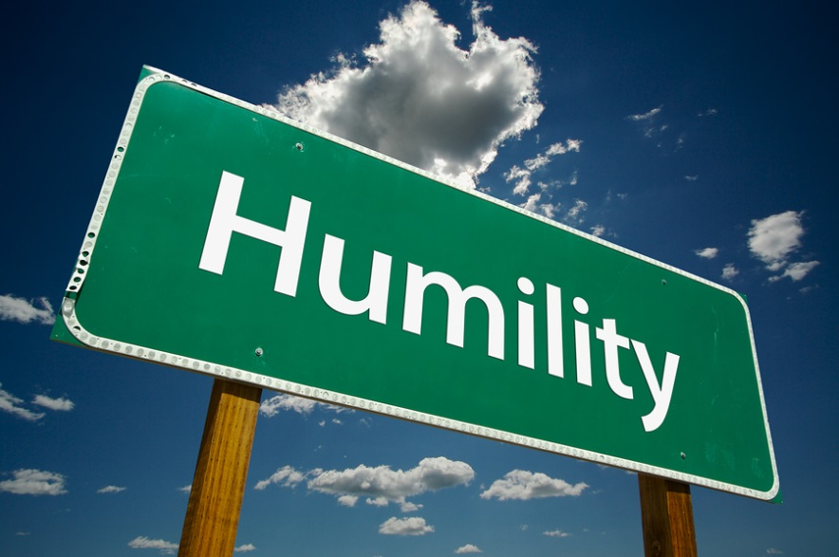
Hod as modesty, humility

We examine and refine the emotional attribute of Hod which Rabbi Jacobsen describes as humility. Humility – and the resulting yielding – should not be confused with weakness and lack of self-esteem. Hod or humility is modesty - it is acknowledgment (from the root of the Hebrew word "hoda'ah"). It is saying "thank you" to G-d. It is clearly recognizing your qualities and strengths and acknowledging that they are not your own; they were given to you by G-d for a higher purpose than just satisfying your own needs. Humility is modesty; it is recognizing how small you are which allows you to realize how large you can become. And that makes humility so formidable.

A full cup cannot be filled. When you're filled with yourself and your needs, "I and nothing else", there is no room for more. When you "empty" yourself before something greater than yourself, your capacity to receive increases beyond your previously perceived limits. Humility is the key to transcendence; to reach beyond yourself. Only true humility gives you the power of total objectivity. Humility is sensitivity; it is healthy shame out of recognition that you can be better than you are and that you can expect more of yourself. Although humility is silent it is not a void. It is a dynamic expression of life that includes all seven qualities of love, discipline, compassion, endurance, humility, bonding and sovereignty.

The Mussar classic of Ramchal, Mesilat Yesharim (Ch. 23) notes the ways to acquire humility:

THERE ARE TWO FACTORS which bring a person to humility: habit and thought. Habit, in this respect, consists in a person's accustoming himself little by little to humility by conducting himself with lowliness after the fashion previously mentioned - occupying a humble seat, walking at the end of the company, and wearing modest garments (respectable but not showy). By accustoming himself to this mode of conduct, he will cause humility to enter into his heart and to inhabit it little by little until it has securely imbedded itself there. For since it is a person's nature to swell with self-importance, it is difficult to root out this inclination at its source. It is only through outward actions, which are under his control, that he can affect his inner self, which is not to a similar extent subject to his direction. All of this is contained in the statement of our Sages of blessed memory (Berachot 17a), "A man should always be subtle in his fear of God;" that is, he should seek devices by which to counteract his nature and its inclination until he is victorious over them.

Thought in respect to the acquisition of humility resolves itself into several considerations. The first is contained in the words of Akavia ben Mahalalel (Avot 3.2), "Know whence you come -from a putrid drop; and where you are going - to a place of dust, worms and maggots; and before whom you are destined to give an accounting - before the King of Kings, the Holy One Blessed be He." In truth, all of these thoughts counteract pride and promote Humility

The second consideration that should be reflected upon for the purpose of acquiring Humility is the variation of circumstances that is produced by time and the many changes to which it gives rise. The rich may easily become poor; the rulers, servants; and the honored, insignificant. If one can so easily be reduced to a condition which he finds so shameful today, how can he feel pride in his own condition, with which he cannot be secure?...

Heading the list of deterrents to humility are ignorance and insufficiency of true understanding. It is to be observed that pride is most prevalent among the more ignorant. Our Sages of blessed memory have said (Sanhedrin 24a), "A sign of pride is poverty of Torah" and (Zohar Balak), "A sign of complete ignorance is self-praise" and (Bava Metzia 85b), "One coin in a pitcher makes a great deal of noise" and (Beresheet Rabbah 16.3), "The barren trees were asked `Why are your voices heard?' and they answered, `So that at least our voices might be heard and remembered.' " We have seen that Mosheh, the choicest of men, was the humblest of all men.

Another deterrent to humility is keeping company with or being served by flatterers, who, to steal a person's heart with their flattery so that he will be of benefit to them, will praise and exalt him by magnifying to their very limits the virtues that he does possess and by attributing to him virtues that he does not possess, his attributes sometimes being the very opposite of those he is being praised for…

THREE MEDITATIONS FOR TONIGHT: TWO MUSSAR, ONE CHASSIDIC

(1)After a long, yet fruitless search for his father's lost donkeys, Saul said to his servant, "We better return home lest my father forget the donkeys and worry about us" (I Shmuel 9:5). Saul humbly considered his servant equally important to himself.

HaShem took note of Saul's humility and awarded him the kingship because of this precious character trait. Human nature strives to find ways to view oneself as more important than others. Conversely the attribute of humility conveys honor and importance to others.

A leader of Klal Yisrael needs humility so that he will value, love, and care for every member of his nation.

For tonight, while gazing at the candles, contemplate the importance and worth of every person. By fighting against human nature, you will merit greatness.

(Tosefta Brachot 4, as cited in Ohr Yisrael)

(2) Later, when Saul was ordained king by Shmuel the Prophet, a small group of people refused to accept his appointment. Instead of silencing them, Saul chose not to take action. Not long afterwards, a cruel enemy, Nachash HaAmoni, threatened to invade Israel. King Saul gathered his army and soundly defeated the enemy, saving his people from terrible danger. When his dedication and success were clearly demonstrated, Saul's kingship was accepted by the entire nation.

When someone disrespects us, the instinctual emotional reaction is to grow resentful and demand respect. However, it is far more beneficial to accept the slight with humility and wait for an opportunity to earn respect.

As we gaze at the 8 lights, contemplate the power of forgiveness, as tonight we pray that Hashem forgives our miss-takes. Now meditate on how someone snubbed you. Did you remain silent? Forgive this person. Next find an opportunity to show your dedication and competence. Even your greatest detractors will admire you.

[Based on the commentary of the Ralbag to I Shmuel 11]

(3) In general, the trait of humility does not actively render a person a prophet, it is merely that arrogance, the absence of humility, disqualifies a person from prophecy. Nevertheless, when a person is not merely devoid of ego but exhibits a truly profound humility, it can be an active factor which causes the Divine spirit to rest on the person. "Humility brings one to prophecy" (Maharsha, Sanhedrin 11a).

Of course, no one is expected to deny his own positive qualities and talents. Even Moshe, who was "extremely humble, more so than any other person on the face of the earth" (Bemidbar 12:3) was aware of his greatness and inherent superiority over others. Nevertheless, a humble person does not allow such knowledge to corrupt him, because he if fully aware that (a) his special qualities are a gift from G-d and (b) if G-d had granted them to another person is quite possible that the other person would have achieved much more. [This feels very Thanksgiving-ish!]

The basic feeling of humility is a pre-requisite for any potential prophet. But in order for a person's humility to be an active force in causing prophecy to rest upon him, it must be of a different quality altogether. A limitation of the above type of humility is that it is calculated. The person initially has feelings of elitism and superiority which are then corrected by honest reasoning. A more profound sensation of humility arises from within the person: he feels inherently meek and small in comparison to others. It is simply obvious that other people are better than him. And such a profound sensation of humility can actually cause a prophetic spirit to rest upon the person.

[Lubavitcher Rebbe, Likutey Sichot 38: 42]

Please see the appendix PDF sent with this e-book which provides a comprehensive list of the daily thanks that flow from a an observant Jew’s lips.
The Shulchan Aruch (Orach Chaim 249:2) rules that it is forbidden on Friday to “establish” a larger meal than one normally eats on weekdays. One may eat an ordinary meal on Friday, though the Shulchan Aruch writes that it is a mitzvah to refrain from eating a meal starting from nine hours into the day. The source of this halacha is the Gemara’s comment in Masechet Gittin (38b) that a certain family in Jerusalem was destroyed because they “established a meal on Erev Shabbat.”
http://blogs.forward.com/the-jew-and-the-carrot/166419/thanksgiving-leftovers-get-a-shabbat-makeover/ . The Gemara in Masechet Shabbat (118b) states: “Even if one prepares something small in honor of Shabbat (meaning a special addition in honor of Shabbat), this constitutes the mitzvah of enjoying Shabbat.”
Please review the dark origins of a supposed day of light: http://www.phillymag.com/news/2012/11/20/dark-origins-thanksgiving/
Check out the obsessive spending related to this day of giving: http://www.businessinsider.com/staggering-facts-thanksgiving-spending-2011-11?op=1
For a brief history of how Hanukah and Thanksgiving have overlapped, please see http://www.chabad.org/holidays/chanukah/article_cdo/aid/2343364/jewish/Chanukah-and-Thanksgiving-A-Brief-History.htm
Note how these flow from the famous verse from I Chronicles 29:11…. וְהַתִּפְאֶרֶת וְהַגְּבוּרָה הַגְּדֻלָּה הוָה לְךָ
On October 6, 1941, the House passed a joint resolution declaring the last Thursday in November to be the legal Thanksgiving Day.
The Romans also enjoyed gladiatorial contests, not dissimilar to the football frenzy found on this day. http://news.psu.edu/story/141233/2009/09/14/research/probing-question-football-similar-roman-gladiator-games
The Rema in Hilchot Hanukah Siman 670 Seif 2. Without zemirot and shvachot (songs and praise), it only has in it "katzat mitzvah" according to the Rema.
http://www.youtube.com/watch?v=_w98wlMByPM
Hod = 15, the sum of all numbers from 1 to 5. Hod expresses and reflects all the five emotions of the heart from Chesed to Hod. The Holy Zohar describes "Binah [the "mother" of the emotions of the heart] extends until Hod."
A free online e-book discussing this question is a must-read: http://www.whoisajew.com/
His Yartzeit is Lag Ba’omer, the 33rd day, according to Sephirah Hod shebeHod.
“Who formed man with wisdom and created within him many openings and many hollows (cavities). It is obvious and known before Your Throne of Glory that if but one of them were to be ruptured or if one of them were to be blocked it would be impossible to survive and to stand before You (even for a short period of time). Blessed are You, Hashem, Who heals all flesh and acts wonderously."
These “qualities” are all gifts of love from HaShem. HaShem loves Klal Yisrael as His "immediate family" and loves each one of us with every aspect of love, care, closeness, and endearment. His love for us is both unconditional and boundless. As He promised: And I will love you and bless you and increase you…” (Devarim 7:12-13). He is THE TRUE LOVE. [See infra]
There are different customs as to the lighting of the Menorah. Some light at sunset. Some light about ten minutes after sunset and some light 1/2 hour after. Some specifically light after the evening service is recited (Arabit). Ideally a person should follow the custom of his father. If this is not known or is inapplicable for any reason, one should follow the custom of the local community
This blessing reads: Blessed are You, Hashem, our G-d, King of the universe, Who bestows kindness upon the culpable, for He has bestowed goodness to me
For example: every morning we say matir assurim, thanking G-d Who releases the bound. This is a request that we not be bound by the material orientation of the body. Indeed, assurim can also mean imprisoned, as mentioned in the acronym above. Each morning, the soul is granted renewed spiritual energy to step beyond the spiritual darkness that it confronts. In response, one should rejoice with the happiness a detainee would feel upon his release from prison. Torat Chaim, Shemot, 73c
But if you are having a meat meal later, after eating cheese and before eating meat, eat something pareve, which does not stick to the palate. Then rinse your mouth, or take a drink, and wash your hands. In addition, many have the custom of waiting a certain period of time -- a half-hour or an hour. After eating certain hard cheeses, a six-hour waiting period is required. http://www.chabad.org/library/article_cdo/aid/547617/jewish/Why-the-wait-between-eating-aged-cheese-and-meat.htm
Either did the Book of Maccabees, where the Hanukah story is found.
http://www.amazon.com/Judith-Judith-Studies-across-Disciplines/dp/1906924155
Shulchan Aruch Harav 242:1-2 holds there is no obligation to eat meat or drink wine on Shabbat. Rather, since it is assumed that most people take more pleasure in eating meat than in other foods, and in drinking wine more than other drinks, therefore they should increase in [consuming] meat and wine according to their means.
Shabbat 21b.: It is incumbent to place the Hanukah lamp at the door of one’s house on the outside; however, if one dwells on an upper floor, one places it in the window that is closest [facing] the public domain. However, in time of danger [from gentiles], it suffices that one place it on one’s table.”
The Gemara in Masechet Avodah Zarah (8a) relates that on the day that Adam Harishon was created, when the sun set and it became dark, having never seen this occurrence before, Adam remarked that it was because of his sin that the world turned black. He feared that the world was about to be destroyed and would return to the tohu vavohu that existed before creation In the morning, when the sky began lighting up again, Adam said that it is the way of the world - the sun sets in the evening and rises in the morning. He was so overjoyed with his discovery that he brought a korban
Psychology researchers aren’t necessarily Thanksgiving experts—they may not know how to make fluffy stuffing, say, or beat the traffic to your in-laws’ house—but they have become a fount of wisdom on thanksgiving (with a small “t”). http://greatergood.berkeley.edu/article/item/tips_for_keeping_a_gratitude_journal
It is forbidden to light a fire on Shabbat, which extends from sunset on Friday evening until nightfall of Saturday night. Therefore, on Friday afternoon, light the menorah before the Shabbat candles. Shabbat candles are traditionally lit eighteen minutes before sundown. Use additional oil or larger candles for the Friday night Hanukah lights, as they must remain lit until one half hour after nightfall - approximately 1½ hours after the Friday afternoon lighting time. Note: The standard 30-minute Hanukah candles cannot be used on Friday.
Not how Aleinu closes by invoking collective recognition of G-d, citing the verse "And the Hashem shall be king over all the earth; in that day there shall be one Hashem with one name" (Zechariah 14:9), the Haftarah for the 1st day of Sukkot, of which Hanukah historically mirrors. See above at pp.
Hillel said if we Jews are not Nevi'im/prophets, הן נביאים בני we are Bnei Nevi'im/the children of prophets, or Prophets-in-Training. Pesachim 66a

